**Chat with an Expert**

**Chat with an Expert**

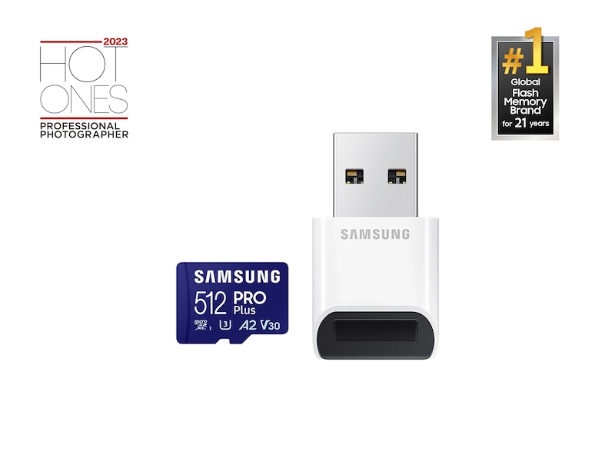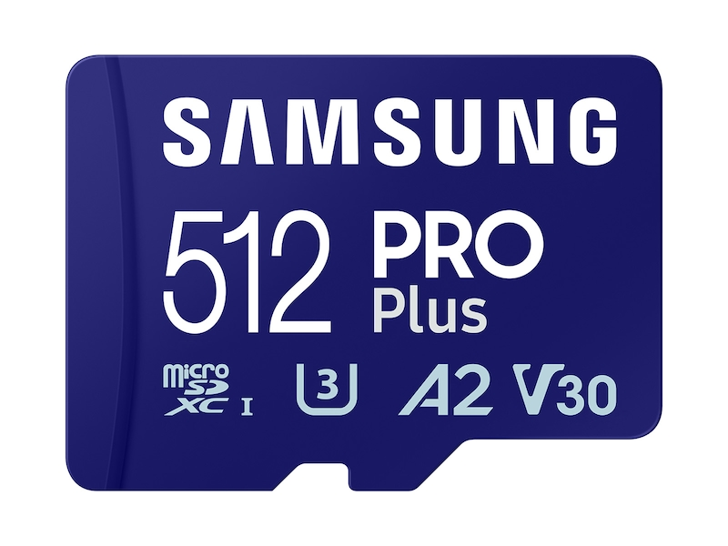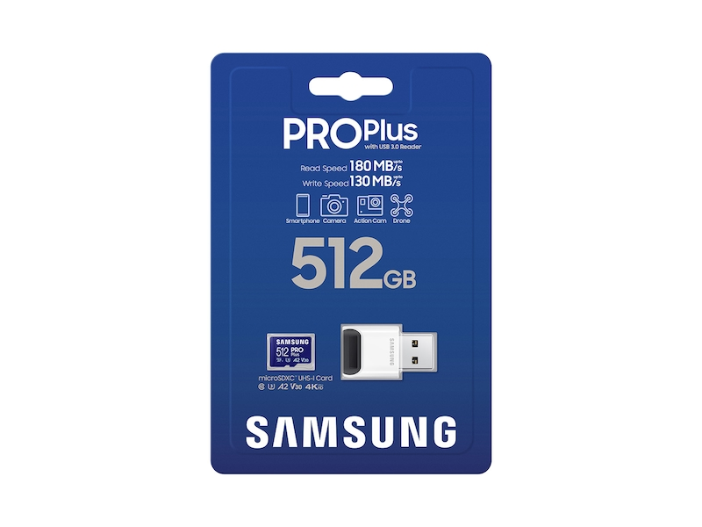

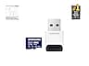



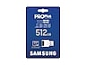















**Samsung.com Advantage**



**Pay in 4 installments**

BOPIS

**In-Store Pickup available**

**Free, No Contact Delivery**